# Task

Technical Implementation:

1. Create a Component
2. On Init, load all the conversations. Let's say,you have 10 conversations.
3. On Expand, full conversation should be displayed on the component.
4. Create section for Open and Closed Conversations.

## Description:

We need a lightning component that we can place on any contact record page and the component will perform following task:

1. List out all conversation in the group of following section (Status field on Conversation):
   1. **Open**
   2. **Closed**

It will be looking this and with showing details

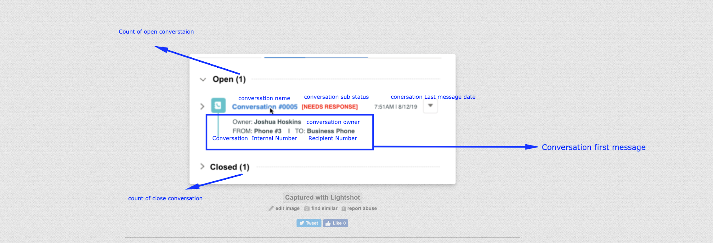

1. When user is expanding any conversation so need to show details of all messages related to that Conversation in the order of Message Message_Date, jus like following screenshot

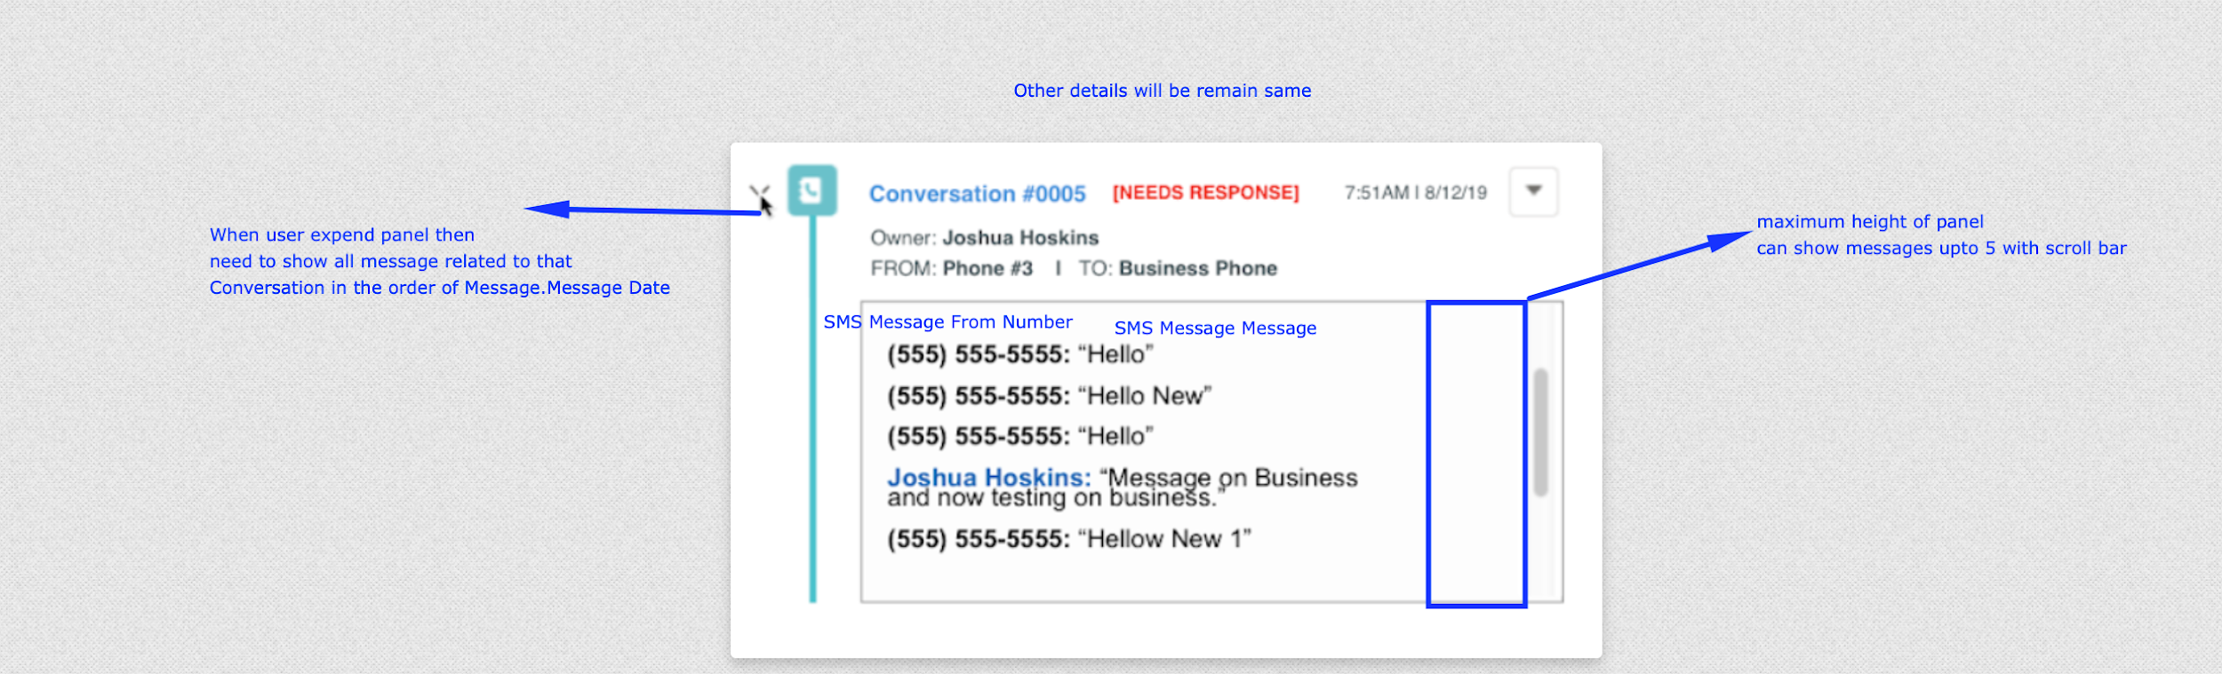

# Sobjects

## SMS Message

* Fields

<fields>

<fullName>Conversation__c</fullName>

<deleteConstraint>SetNull</deleteConstraint>

<externalId>false</externalId>

<label>Conversation</label>

<referenceTo>Conversation__c</referenceTo>

<relationshipLabel>SMS Messages</relationshipLabel>

<relationshipName>SMS_Messages</relationshipName>

<required>false</required>

<trackTrending>false</trackTrending>

<type>Lookup</type>

</fields>

<fields>

<fullName>From_Phone__c</fullName>

<deprecated>false</deprecated>

<description>The From number converted to a Phone field.</description>

<externalId>false</externalId>

<inlineHelpText>The From number converted to a Phone field.</inlineHelpText>

<label>From Phone</label>

<required>false</required>

<trackTrending>false</trackTrending>

<type>Phone</type>

</fields>

<fields>

<fullName>Message_Date__c</fullName>

<deprecated>false</deprecated>

<description>The date that this message was sent/received.</description>

<externalId>false</externalId>

<inlineHelpText>The date that this message was sent/received.</inlineHelpText>

<label>Message Date</label>

<required>false</required>

<trackTrending>false</trackTrending>

<type>DateTime</type>

</fields>

<fields>

<fullName>Message_Full__c</fullName>

<deprecated>false</deprecated>

<description>The full text of the message. This is helpful when a message exceeds 255 characters.</description>

<externalId>false</externalId>

<inlineHelpText>The full text of the message which allows for greater than 255 characters.</inlineHelpText>

<label>Message (Full)</label>

<length>131072</length>

<trackTrending>false</trackTrending>

<type>LongTextArea</type>

<visibleLines>4</visibleLines>

</fields>

<fields>

<fullName>Message_Length__c</fullName>

<deprecated>false</deprecated>

<description>The number of characters in this message.</description>

<externalId>false</externalId>

<formula>LEN( Message__c )</formula>

<formulaTreatBlanksAs>BlankAsZero</formulaTreatBlanksAs>

<inlineHelpText>The number of characters in this message.</inlineHelpText>

<label>Message Length</label>

<precision>18</precision>

<required>false</required>

<scale>0</scale>

<trackTrending>false</trackTrending>

<type>Number</type>

<unique>false</unique>

</fields>

<fields>

<fullName>Message__c</fullName>

<deprecated>false</deprecated>

<description>The body of the message.</description>

<externalId>false</externalId>

<inlineHelpText>The body of the message.</inlineHelpText>

<label>Message</label>

<required>false</required>

<trackTrending>false</trackTrending>

<type>TextArea</type>

</fields>

<fields>

<fullName>Status__c</fullName>

<deprecated>false</deprecated>

<description>The delivery status of this message. Incoming messages are &quot;Received&quot;. Outgoing messages are either &quot;Pending&quot;, &quot;Sent&quot;, &quot;Delivered&quot;, &quot;Undelivered&quot;, or &quot;Error&quot;.</description>

<externalId>false</externalId>

<inlineHelpText>The delivery status of this message. Incoming messages are &quot;Received&quot;. Outgoing messages are either &quot;Pending&quot;, &quot;Sent&quot;, &quot;Delivered&quot;, &quot;Undelivered&quot;, or &quot;Error&quot;.</inlineHelpText>

<label>Status</label>

<required>false</required>

<trackTrending>false</trackTrending>

<type>Picklist</type>

<valueSet>

<valueSetDefinition>

<sorted>false</sorted>

<value>

<fullName>Pending</fullName>

<default>false</default>

<label>Pending</label>

</value>

<value>

<fullName>Received</fullName>

<default>false</default>

<label>Received</label>

</value>

<value>

<fullName>Replied</fullName>

<default>false</default>

<label>Replied</label>

</value>

<value>

<fullName>Sent</fullName>

<default>false</default>

<label>Sent</label>

</value>

<value>

<fullName>Delivered</fullName>

<default>false</default>

<label>Delivered</label>

</value>

<value>

<fullName>Undelivered</fullName>

<default>false</default>

<label>Undelivered</label>

</value>

<value>

<fullName>Error</fullName>

<default>false</default>

<label>Error</label>

</value>

</valueSetDefinition>

</valueSet>

</fields>

<fields>

<fullName>To_Phone__c</fullName>

<deprecated>false</deprecated>

<description>The To number converted to a Phone field.</description>

<externalId>false</externalId>

<inlineHelpText>The To number converted to a Phone field.</inlineHelpText>

<label>To Phone</label>

<required>false</required>

<trackTrending>false</trackTrending>

<type>Phone</type>

</fields>

<fields>

<fullName>Type__c</fullName>

<deprecated>false</deprecated>

<description>The direction of this message. The direction is either Outgoing or Incoming.</description>

<externalId>false</externalId>

<inlineHelpText>The direction of this message. The direction is either Outgoing or Incoming.</inlineHelpText>

<label>Direction</label>

<required>false</required>

<trackTrending>false</trackTrending>

<type>Picklist</type>

<valueSet>

<valueSetDefinition>

<sorted>false</sorted>

<value>

<fullName>Incoming</fullName>

<default>false</default>

<label>Incoming</label>

</value>

<value>

<fullName>Outgoing</fullName>

<default>false</default>

<label>Outgoing</label>

</value>

</valueSetDefinition>

</valueSet>

</fields>

<fields>

<fullName>User__c</fullName>

<deleteConstraint>SetNull</deleteConstraint>

<deprecated>false</deprecated>

<description>The related User.</description>

<externalId>false</externalId>

<inlineHelpText>The related User.</inlineHelpText>

<label>User</label>

<referenceTo>User</referenceTo>

<relationshipName>SMS_Messages</relationshipName>

<required>false</required>

<trackTrending>false</trackTrending>

<type>Lookup</type>

</fields>

## Convestation

* Fields

<fields>

<fullName>Closed__c</fullName>

<externalId>false</externalId>

<formula>ISPICKVAL(Status__c, &quot;Closed&quot;)</formula>

<label>Closed</label>

<trackTrending>false</trackTrending>

<type>Checkbox</type>

</fields>

<fields>

<fullName>Internal_Phone__c</fullName>

<externalId>false</externalId>

<label>Internal Phone</label>

<length>255</length>

<required>false</required>

<trackTrending>false</trackTrending>

<type>Text</type>

<unique>false</unique>

</fields>

<fields>

<fullName>Last_Message_Date_Time__c</fullName>

<externalId>false</externalId>

<formula>Last_Message__r.Message_Date__c</formula>

<label>Last Message Date/Time</label>

<required>false</required>

<trackTrending>false</trackTrending>

<type>DateTime</type>

</fields>

<fields>

<fullName>Last_Message__c</fullName>

<deleteConstraint>SetNull</deleteConstraint>

<externalId>false</externalId>

<label>Last Message</label>

<referenceTo>SMS_Message__c</referenceTo>

<relationshipLabel>Conversations</relationshipLabel>

<relationshipName>Conversations</relationshipName>

<required>false</required>

<trackTrending>false</trackTrending>

<type>Lookup</type>

</fields>

<fields>

<fullName>Last_Message_Direction__c</fullName>

<externalId>false</externalId>

<formula>TEXT( Last_Message__r.Type__c)</formula>

<label>Last Message Direction</label>

<required>false</required>

<trackTrending>false</trackTrending>

<type>Text</type>

<unique>false</unique>

</fields>

<fields>

<fullName>Last_Message_Status__c</fullName>

<externalId>false</externalId>

<formula>TEXT(Last_Message__r.Status__c)</formula>

<label>Last Message Status</label>

<required>false</required>

<trackTrending>false</trackTrending>

<type>Text</type>

<unique>false</unique>

</fields>

<fields>

<fullName>Recipient_Phone__c</fullName>

<externalId>false</externalId>

<label>Recipient Phone</label>

<length>255</length>

<required>false</required>

<trackTrending>false</trackTrending>

<type>Text</type>

<unique>false</unique>

</fields>

<fields>

<fullName>Status__c</fullName>

<externalId>false</externalId>

<label>Status</label>

<required>false</required>

<trackTrending>false</trackTrending>

<type>Picklist</type>

<valueSet>

<restricted>true</restricted>

<valueSetDefinition>

<sorted>false</sorted>

<value>

<fullName>Open</fullName>

<default>false</default>

<label>Open</label>

</value>

<value>

<fullName>Closed</fullName>

<default>false</default>

<label>Closed</label>

</value>

</valueSetDefinition>

</valueSet>

</fields>

<fields>

<fullName>Sub_Status__c</fullName>

<externalId>false</externalId>

<formula>&apos;&apos;</formula>

<label>Sub-Status</label>

<required>false</required>

<trackTrending>false</trackTrending>

<type>Text</type>

<unique>false</unique>

Task2

1. Create a checkbox on Account “Userupdated” and default value is “false”.
2. Create a lightning button “Table View” on Account page and on click of lightning button, pass all the parameters (field values of Account) to the child component and display the values in the table.
3. User should be able to update the table and save it.
4. Once saved, the checkbox “Userupdated” should be true.
5. If the checkbox is true, then the button “Table View” should be disabled.